Exp5
JAVASCRIPT – DOM ELEMENTS AND EVENTS
Shortest and Longest Word
Code:
<!DOCTYPE html>
<html>
<head>
<title>Shortest and Longest Word</title>

<style>
body {
font-family: Arial, sans-serif;
background-color: lightblue;
text-align: center;
padding: 40px;
}

.box {
background-color: white;
padding: 25px;
border-radius: 15px;
max-width: 500px;
margin: auto;
box-shadow: 0 0 10px gray;
}

input {
padding: 10px;
width: 80%;
}

button {
padding: 10px 20px;
margin: 15px;
background-color: blue;
color: white;
border: none;
cursor: pointer;
}

button:hover {
background-color: darkblue;
}

#result {
color: green;
font-weight: bold;
}

footer {
margin-top: 25px;
font-size: 14px;
}
</style>
</head>

<body>

<div class="box">
<h1>Shortest and Longest Word</h1>

<p>Enter a sentence:</p>

<input type="text" id="sentence"
value="Web Development Tutorial">

<br>

<button onclick="findWords()">Find Words</button>

<p id="result"></p>

<footer>
Register Number: URK24CS9060<br>
BATCH 6
</footer>
</div>

<script>
function findWords() {
var sentence =
document.getElementById("sentence").value;

var words = sentence.trim().split(/\s+/);

var shortest = words[0];
var longest = words[0];

for (var i = 1; i < words.length; i++) {
if (words[i].length < shortest.length) {
shortest = words[i];
}

if (words[i].length > longest.length) {
longest = words[i];
}
}

document.getElementById("result").innerHTML =
"Shortest Word: " + shortest +
"<br>Longest Word: " + longest;
}
</script>

</body>
</html>

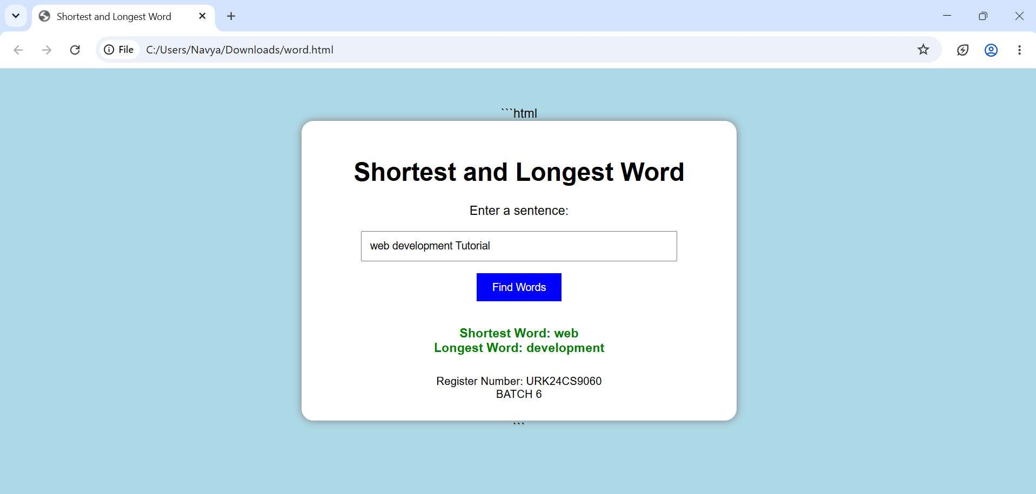
BMI Calculator
Code:
<!DOCTYPE html>
<html>
<head>
<title>BMI Calculator</title>

<style>
body {
font-family: Arial, sans-serif;
background-color: lightblue;
text-align: center;
padding: 40px;
}

.container {
background-color: white;
width: 400px;
max-width: 90%;
margin: auto;
padding: 25px;
border-radius: 15px;
box-shadow: 0 0 10px gray;
}

input {
padding: 10px;
margin: 10px;
width: 80%;
}

button {
background-color: blue;
color: white;
padding: 10px 20px;
border: none;
cursor: pointer;
}

button:hover {
background-color: darkblue;
}

#score, #type {
color: green;
font-weight: bold;
}

footer {
margin-top: 25px;
font-size: 14px;
}
</style>
</head>

<body>

<div class="container">

<h1>Calculate your Body Mass Index (BMI)!</h1>

<fieldset>
<legend>BMI Details</legend>

Weight (in kilograms):
<input type="number" id="weight"
placeholder="Enter weight in kg" step="any">
<br>

Height (in meters):
<input type="number" id="height"
placeholder="Enter height in meters" step="any">
<br>

<button onclick="calculate()">Get BMI!</button>
</fieldset>

<p>
Your BMI is <span id="score"></span>.
<br><br>
Your body type is <span id="type"></span>.
</p>

<footer>
Register Number: URK24CS9060
<br>
BATCH 6
</footer>

</div>

<script>
function calculate() {

// Get weight and height from input boxes
var weight = parseFloat(
document.getElementById("weight").value
);

var height = parseFloat(
document.getElementById("height").value
);

// Calculate BMI
var bmi = weight / (height * height);

// Display BMI score
document.getElementById("score").innerHTML =
bmi.toFixed(2);

// Determine body type using the PDF criteria
var type;

if (bmi < 18) {
type = "Underweight";
} else if (bmi <= 25) {
type = "Normal";
} else if (bmi <= 30) {
type = "Overweight";
} else {
type = "Obese";
}

// Display body type
document.getElementById("type").innerHTML = type;
}
</script>

</body>
</html>
Output:

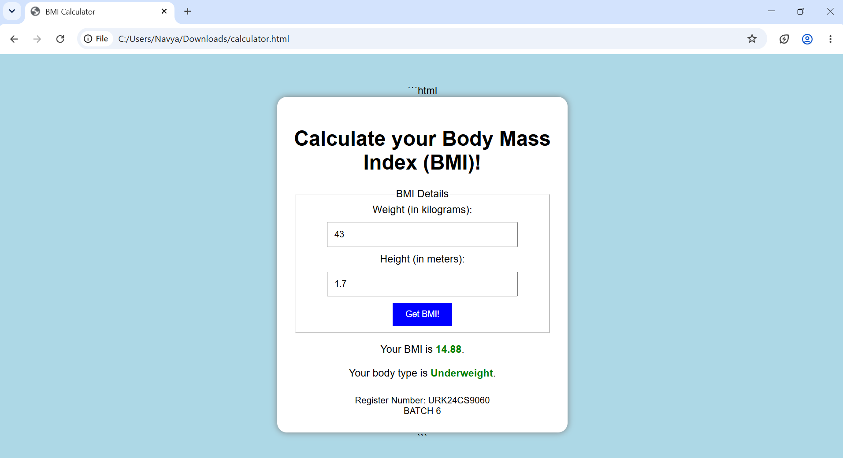
Fruit Farm
Code:
<!DOCTYPE html>
<html>
<head>
<title>Fruit Farm</title>

<style>
body {
font-family: Arial, sans-serif;
text-align: center;
background-color: #f0fff0;
padding: 20px;
}

h1 {
color: green;
}

input {
padding: 8px;
width: 80px;
margin: 5px;
}

button {
padding: 10px 20px;
background-color: green;
color: white;
border: none;
border-radius: 5px;
cursor: pointer;
}

#garden {
display: grid;
gap: 10px;
justify-content: center;
margin-top: 25px;
}

.fruit {
background-color: white;
border: 2px solid lightgreen;
border-radius: 10px;
padding: 10px;
font-size: 40px;
}

footer {
margin-top: 30px;
color: gray;
}
</style>
</head>

<body>

<h1>🍎 Fruit Farm 🍊</h1>

<label>Number of Rows:</label>
<input type="number" id="rows" min="1" max="10" value="3">

<br>

<label>Number of Columns:</label>
<input type="number" id="cols" min="1" max="10" value="4">

<br><br>

<button onclick="createFarm()">Generate Fruit Farm</button>

<div id="garden"></div>

<footer>
Register Number: URK24CS9060 | BATCH 6
</footer>

<script>
function createFarm() {
let rows = parseInt(document.getElementById("rows").value);
let cols = parseInt(document.getElementById("cols").value);

let garden = document.getElementById("garden");
garden.innerHTML = "";

if (isNaN(rows) || isNaN(cols) ||
rows < 1 || cols < 1 ||
rows > 10 || cols > 10) {
alert("Enter rows and columns between 1 and 10.");
return;
}

garden.style.gridTemplateColumns =
"repeat(" + cols + ", 80px)";

for (let i = 0; i < rows * cols; i++) {
let fruit = document.createElement("div");
fruit.className = "fruit";

if (Math.random() < 0.5) {
fruit.innerHTML = "🍎";
fruit.title = "Apple";
} else {
fruit.innerHTML = "🍊";
fruit.title = "Orange";
}

garden.appendChild(fruit);
}
}

createFarm();
</script>

</body>
</html>
Output:
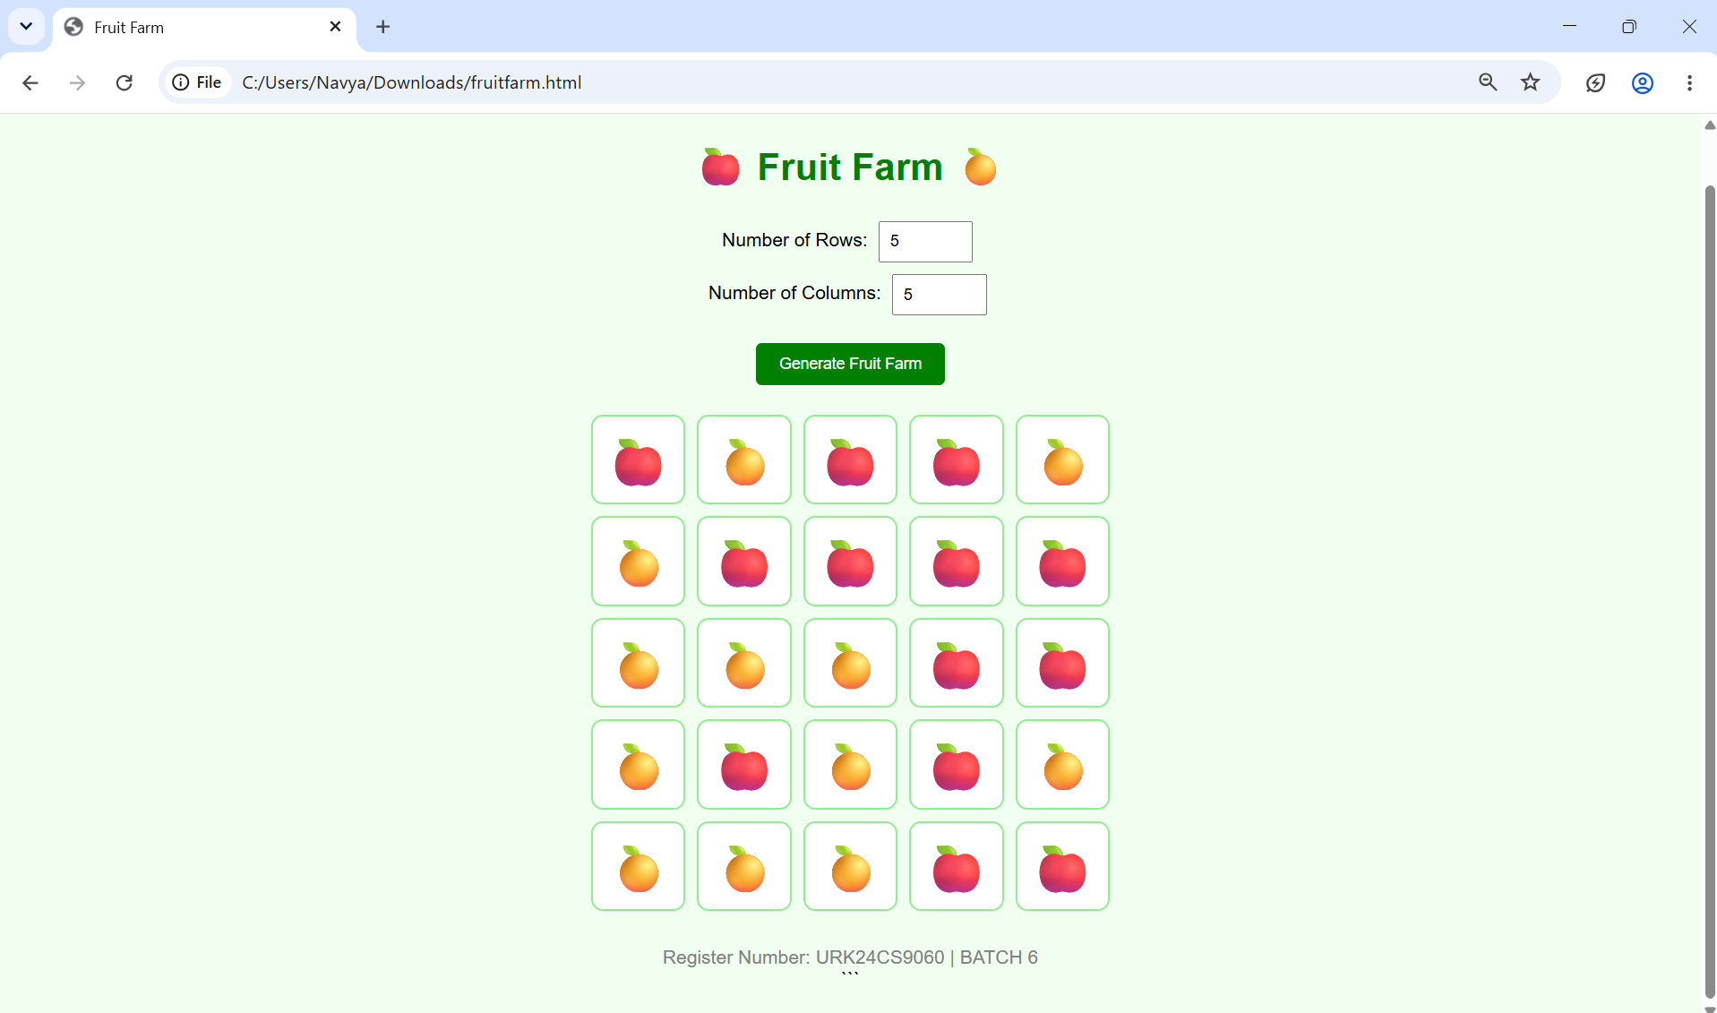
: Currency Converter
Code:
<!DOCTYPE html>
<html>
<head>
<title>Currency Converter</title>

<style>
body {
font-family: Arial, sans-serif;
background-color: #eaf4ff;
text-align: center;
padding: 40px;
}

.container {
background-color: white;
padding: 25px;
max-width: 400px;
margin: auto;
border-radius: 12px;
box-shadow: 0 0 10px lightgray;
}

h1 {
color: #145da0;
}

input, select {
padding: 10px;
width: 90%;
margin: 10px 0;
box-sizing: border-box;
}

button {
background-color: #145da0;
color: white;
padding: 12px 20px;
border: none;
border-radius: 5px;
cursor: pointer;
}

#result {
color: green;
font-size: 20px;
font-weight: bold;
margin-top: 20px;
}

footer {
margin-top: 25px;
color: gray;
font-size: 14px;
}
</style>
</head>

<body>

<div class="container">
<h1>Currency Converter 💱</h1>

<input type="number" id="amount"
placeholder="Enter amount" min="0">

<select id="conversion">
<option value="INRtoUSD">INR to USD</option>
<option value="USDtoINR">USD to INR</option>
</select>

<br>

<button onclick="convertCurrency()">Convert</button>

<p id="result"></p>
</div>

<footer>
Register Number: URK24CS9060 | BATCH 6
</footer>

<script>
function convertCurrency() {
let amount = parseFloat(
document.getElementById("amount").value
);

let conversion =
document.getElementById("conversion").value;

let result = document.getElementById("result");

if (isNaN(amount) || amount < 0) {
result.innerHTML = "Please enter a valid amount.";
return;
}

if (conversion === "INRtoUSD") {
let dollars = amount * 0.015;
result.innerHTML =
"USD: $" + dollars.toFixed(2);
} else {
let rupees = amount * 67.12;
result.innerHTML =
"INR: ₹" + rupees.toFixed(2);
}
}
</script>

</body>
</html>
Output:
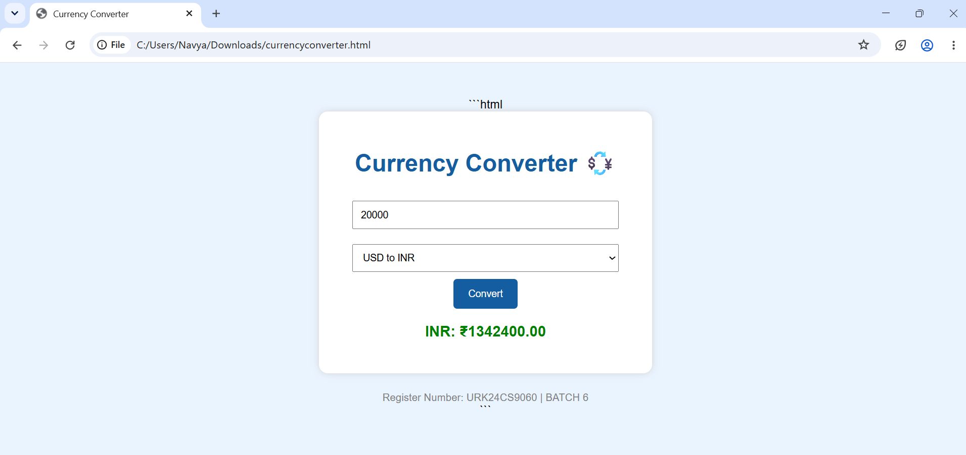
Coin Flip
Code:
<!DOCTYPE html>
<html>
<head>
<title>Coin Flip</title>

<style>
body {
font-family: Arial, sans-serif;
text-align: center;
background-color: #fff8e7;
padding: 30px;
}

h1 {
color: #8b4513;
}

input {
padding: 10px;
width: 100px;
margin: 10px;
}

button {
padding: 10px 20px;
background-color: #8b4513;
color: white;
border: none;
border-radius: 5px;
cursor: pointer;
}

#coins {
display: flex;
justify-content: center;
flex-wrap: wrap;
gap: 15px;
margin: 25px;
}

.coin {
width: 80px;
height: 80px;
border-radius: 50%;
border: 4px solid goldenrod;
background-color: #ffdf70;
display: flex;
align-items: center;
justify-content: center;
font-size: 14px;
font-weight: bold;
color: #704214;
}

#result {
font-size: 18px;
font-weight: bold;
color: darkgreen;
}

footer {
margin-top: 30px;
color: gray;
}
</style>
</head>

<body>

<h1>🪙 Coin Flip</h1>

<label>Number of Coins:</label>
<input type="number" id="number" min="1" max="30" value="5">

<br>

<button onclick="flipCoins()">Flip Coins</button>

<div id="coins"></div>

<p id="result"></p>

<footer>
Register Number: URK24CS9060 | BATCH 6
</footer>

<script>
function flipCoins() {
let number = parseInt(
document.getElementById("number").value
);

let coins = document.getElementById("coins");
let result = document.getElementById("result");

coins.innerHTML = "";
result.innerHTML = "";

if (isNaN(number) || number < 1 || number > 30) {
alert("Enter a number between 1 and 30.");
return;
}

let heads = 0;
let tails = 0;

for (let i = 0; i < number; i++) {
let coin = document.createElement("div");
coin.className = "coin";

if (Math.random() < 0.5) {
coin.innerHTML = "HEADS";
heads++;
} else {
coin.innerHTML = "TAILS";
tails++;
}
coins.appendChild(coin);
}

result.innerHTML =
"Heads: " + heads + "<br>" +
"Tails: " + tails;
}
</script>

</body>
</html>
Output:
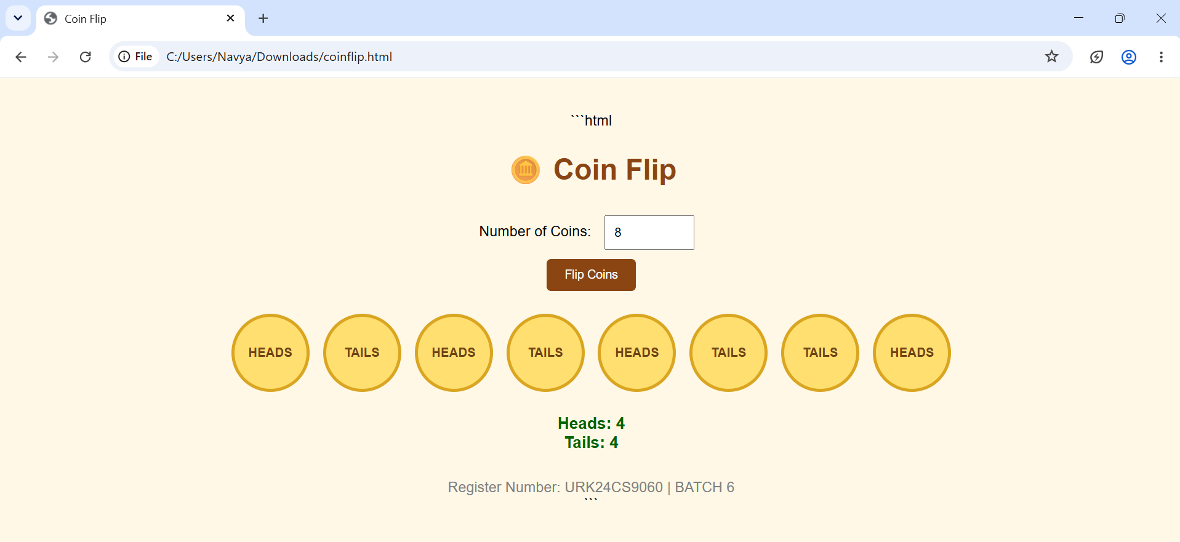
Birthday Cake Order Form
Code:


